**Discover the Best Hair Salon in North York: A Guide to Flawless Style**

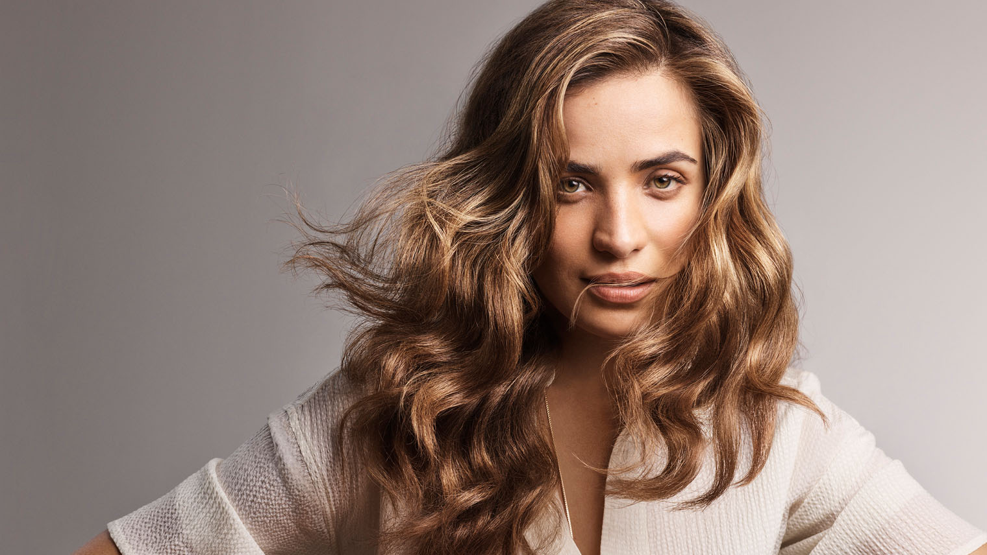

Finding the **best hair salon in North York** is no small feat. With so many options, each promising exceptional service, it can be overwhelming to choose the right one. Whether you're after a sleek haircut, a bold new color, or intricate styling, you deserve a salon that not only meets your expectations but exceeds them. In this guide, we’ll walk you through the top salons in North York, where highly skilled professionals will craft your ideal look while delivering the pampering experience you deserve.

**Why Choosing the Right Salon Matters**

Your hair is more than just a part of your appearance—it’s an expression of your personality, a reflection of your style, and sometimes, even a [best hair salon toronto](https://www.caliahair.com/) confidence booster. A great hair salon does more than offer a haircut; it transforms your entire look, enhances your features, and leaves you feeling refreshed. The best salons in North York combine advanced techniques with top-tier products and a commitment to ensuring every client leaves looking their absolute best.

From classic cuts to avant-garde styles, these salons are at the forefront of **haircare trends** and can accommodate any preference or hair type. Here’s how to navigate North York’s finest salons to find the one that aligns perfectly with your hair goals.

**What to Look for in a North York Hair Salon**

Before we dive into specific recommendations, let’s explore the qualities that define the **best hair salon** in North York:

**1. Expertise and Skill Level**

The top salons employ highly trained and experienced stylists who are masters of their craft. Whether it's precision cutting, advanced coloring techniques like **balayage** or **ombre**, or detailed styling, their proficiency should shine through in their portfolio of work.

**2. Range of Services**

A quality hair salon should offer a wide range of services beyond basic cuts and color. Look for places that specialize in treatments such as **keratin treatments**, **hair extensions**, or **specialized curly hair care**, ensuring they can meet any hair-related need you might have.

**3. Client-Centered Approach**

The best salons focus on understanding your personal style and hair type, tailoring their services accordingly. A thorough consultation is crucial in establishing trust and ensuring your stylist knows exactly what you’re looking for before any scissors touch your hair.

**4. Use of Premium Products**

Top-tier salons in North York invest in high-quality hair products that nourish and protect your hair. Whether it’s sulfate-free shampoos, **organic coloring solutions**, or treatments designed to maintain the integrity of your hair, the products used in the salon should contribute to long-lasting results.

**5. Cleanliness and Ambiance**

A pristine, well-maintained space with a relaxing atmosphere sets the tone for a positive salon experience. You should feel comfortable and at ease the moment you walk in, knowing that the salon prioritizes both hygiene and client comfort.

**Top Salons in North York for Flawless Style**

Now that you know what to look for, let’s explore the **best hair salons in North York** that excel in all these categories.

**1. Haartek Salon**

**Haartek Salon** is one of North York’s leading hair destinations, offering expert-level services with a focus on personalized care. Their team of seasoned professionals excels in creating customized styles for every client. Whether you're looking for a quick trim or an entirely new look, Haartek will ensure you leave with confidence.

**What Sets Haartek Apart:**

* **Custom Color Services**: Haartek’s colorists are known for their precision and creativity, offering everything from natural highlights to daring, bold hues.
* **Luxury Treatments**: The salon offers a range of treatments, from smoothing **Brazilian blowouts** to **intensive hair masks** that restore moisture and shine.
* **Client-Centric Consultations**: They offer in-depth consultations to understand your style preferences and hair goals before starting any service.

**2. Valvano Salon Spa**

**Valvano Salon Spa** is a high-end salon and spa located in the heart of North York. Specializing in modern cuts, color corrections, and advanced styling, Valvano has built a reputation for delivering sophisticated looks that cater to each client’s unique preferences.

**What Makes Valvano Exceptional:**

* **Innovative Haircuts**: The stylists at Valvano are up-to-date with the latest trends and cutting techniques, ensuring you’ll receive a look that’s both on-trend and tailored to your face shape.
* **Advanced Color Techniques**: From **balayage** to color melts, the salon’s experts can transform your hair color to match the latest styles or give you a subtle, natural glow.
* **Pampering Experience**: With an attached spa, Valvano also offers skin treatments, making it a one-stop destination for all your beauty needs.

**3. LAC + CO**

For a true luxury experience, **LAC + CO** in North York provides elevated services that combine high-end haircare with modern trends. Known for its sleek ambiance and editorial-level styling, LAC + CO attracts a discerning clientele that values precision and attention to detail.

**Why LAC + CO is a Top Choice:**

* **Celebrity-Level Styling**: The salon’s stylists have experience working on fashion shoots and with high-profile clients, ensuring you’ll receive a cut or color that feels straight from the runway.
* **Top-Notch Hair Care Products**: The salon uses premium products like **Olaplex** and **Kevin Murphy**, ensuring that your hair stays healthy and vibrant between appointments.
* **Editorial Expertise**: Whether you're looking for an edgy cut or a glamorous blowout, the stylists are skilled in creating high-fashion looks.

**4. Urban Roots Hair Studio**

**Urban Roots Hair Studio** brings an eco-friendly touch to hair care in North York. This sustainable salon prides itself on using only cruelty-free, environmentally conscious products while still delivering high-quality styling services.

**Why Urban Roots Stands Out:**

* **Eco-Friendly Practices**: Urban Roots is committed to reducing its environmental impact, using sustainable products and practices throughout the salon.
* **Curly Hair Specialists**: Known for their expertise in curly hair, the stylists here know how to work with texture, offering specialized cuts and treatments to enhance your natural curls.
* **Relaxing Atmosphere**: The salon’s cozy, laid-back vibe is perfect for clients seeking a more intimate and calming salon experience.

**5. One2One Studio**

**One2One Studio** prides itself on personalized, one-on-one service, offering a truly bespoke experience. This boutique salon in North York is ideal for clients who want undivided attention from their stylist and a look that is entirely customized to their vision.

**What One2One Studio Offers:**

* **Bespoke Haircuts**: The stylists here work closely with each client to craft a cut that perfectly complements their features and lifestyle.
* **Specialized Color**: Known for their expertise in **hair coloring** techniques, One2One offers services like **dimensional highlights**, vivid colors, and soft ombre looks.
* **Exclusive Atmosphere**: With a focus on quality over quantity, the salon offers a more intimate experience than larger chain salons, ensuring every detail of your visit is exceptional.

**Conclusion: Your Perfect Hair Salon in North York Awaits**

Choosing the **best hair salon in North York** is about more than just getting a haircut—it’s about finding a place where you feel understood, valued, and styled to perfection. Whether you're looking for a trendy new color, a timeless cut, or a salon that understands how to care for your unique hair type, North York is home to an array of top-tier salons. Each of these destinations offers its own distinctive take on beauty, combining exceptional skill with a dedication to making you look and feel your best.